  
Arduino Uno ROS Publisher  
Documentation

### Contactless Temperature Monitor

Robbie Andersen, Kai Bushby, Mitch Stevens

## Summary

This section will demonstrate publishing the thermal sensor reading from the Arduino Uno into ROS RaspberryPi. The wiring of the Arduino and sensor are documented in the XC-3704 IR Temperature Sensor documentation.

## Equipment

* Arduino Uno
* Laptop loaded with Arduino IDE
* Raspberry Pi 3 / 4 loaded with ubiquity ROS

## Method

1. Search for ‘Rosserial’ under the Library Manager and install the “Rosserial Arduino Library”.

To get to the Library Manager: Tools > Manage Libraries...

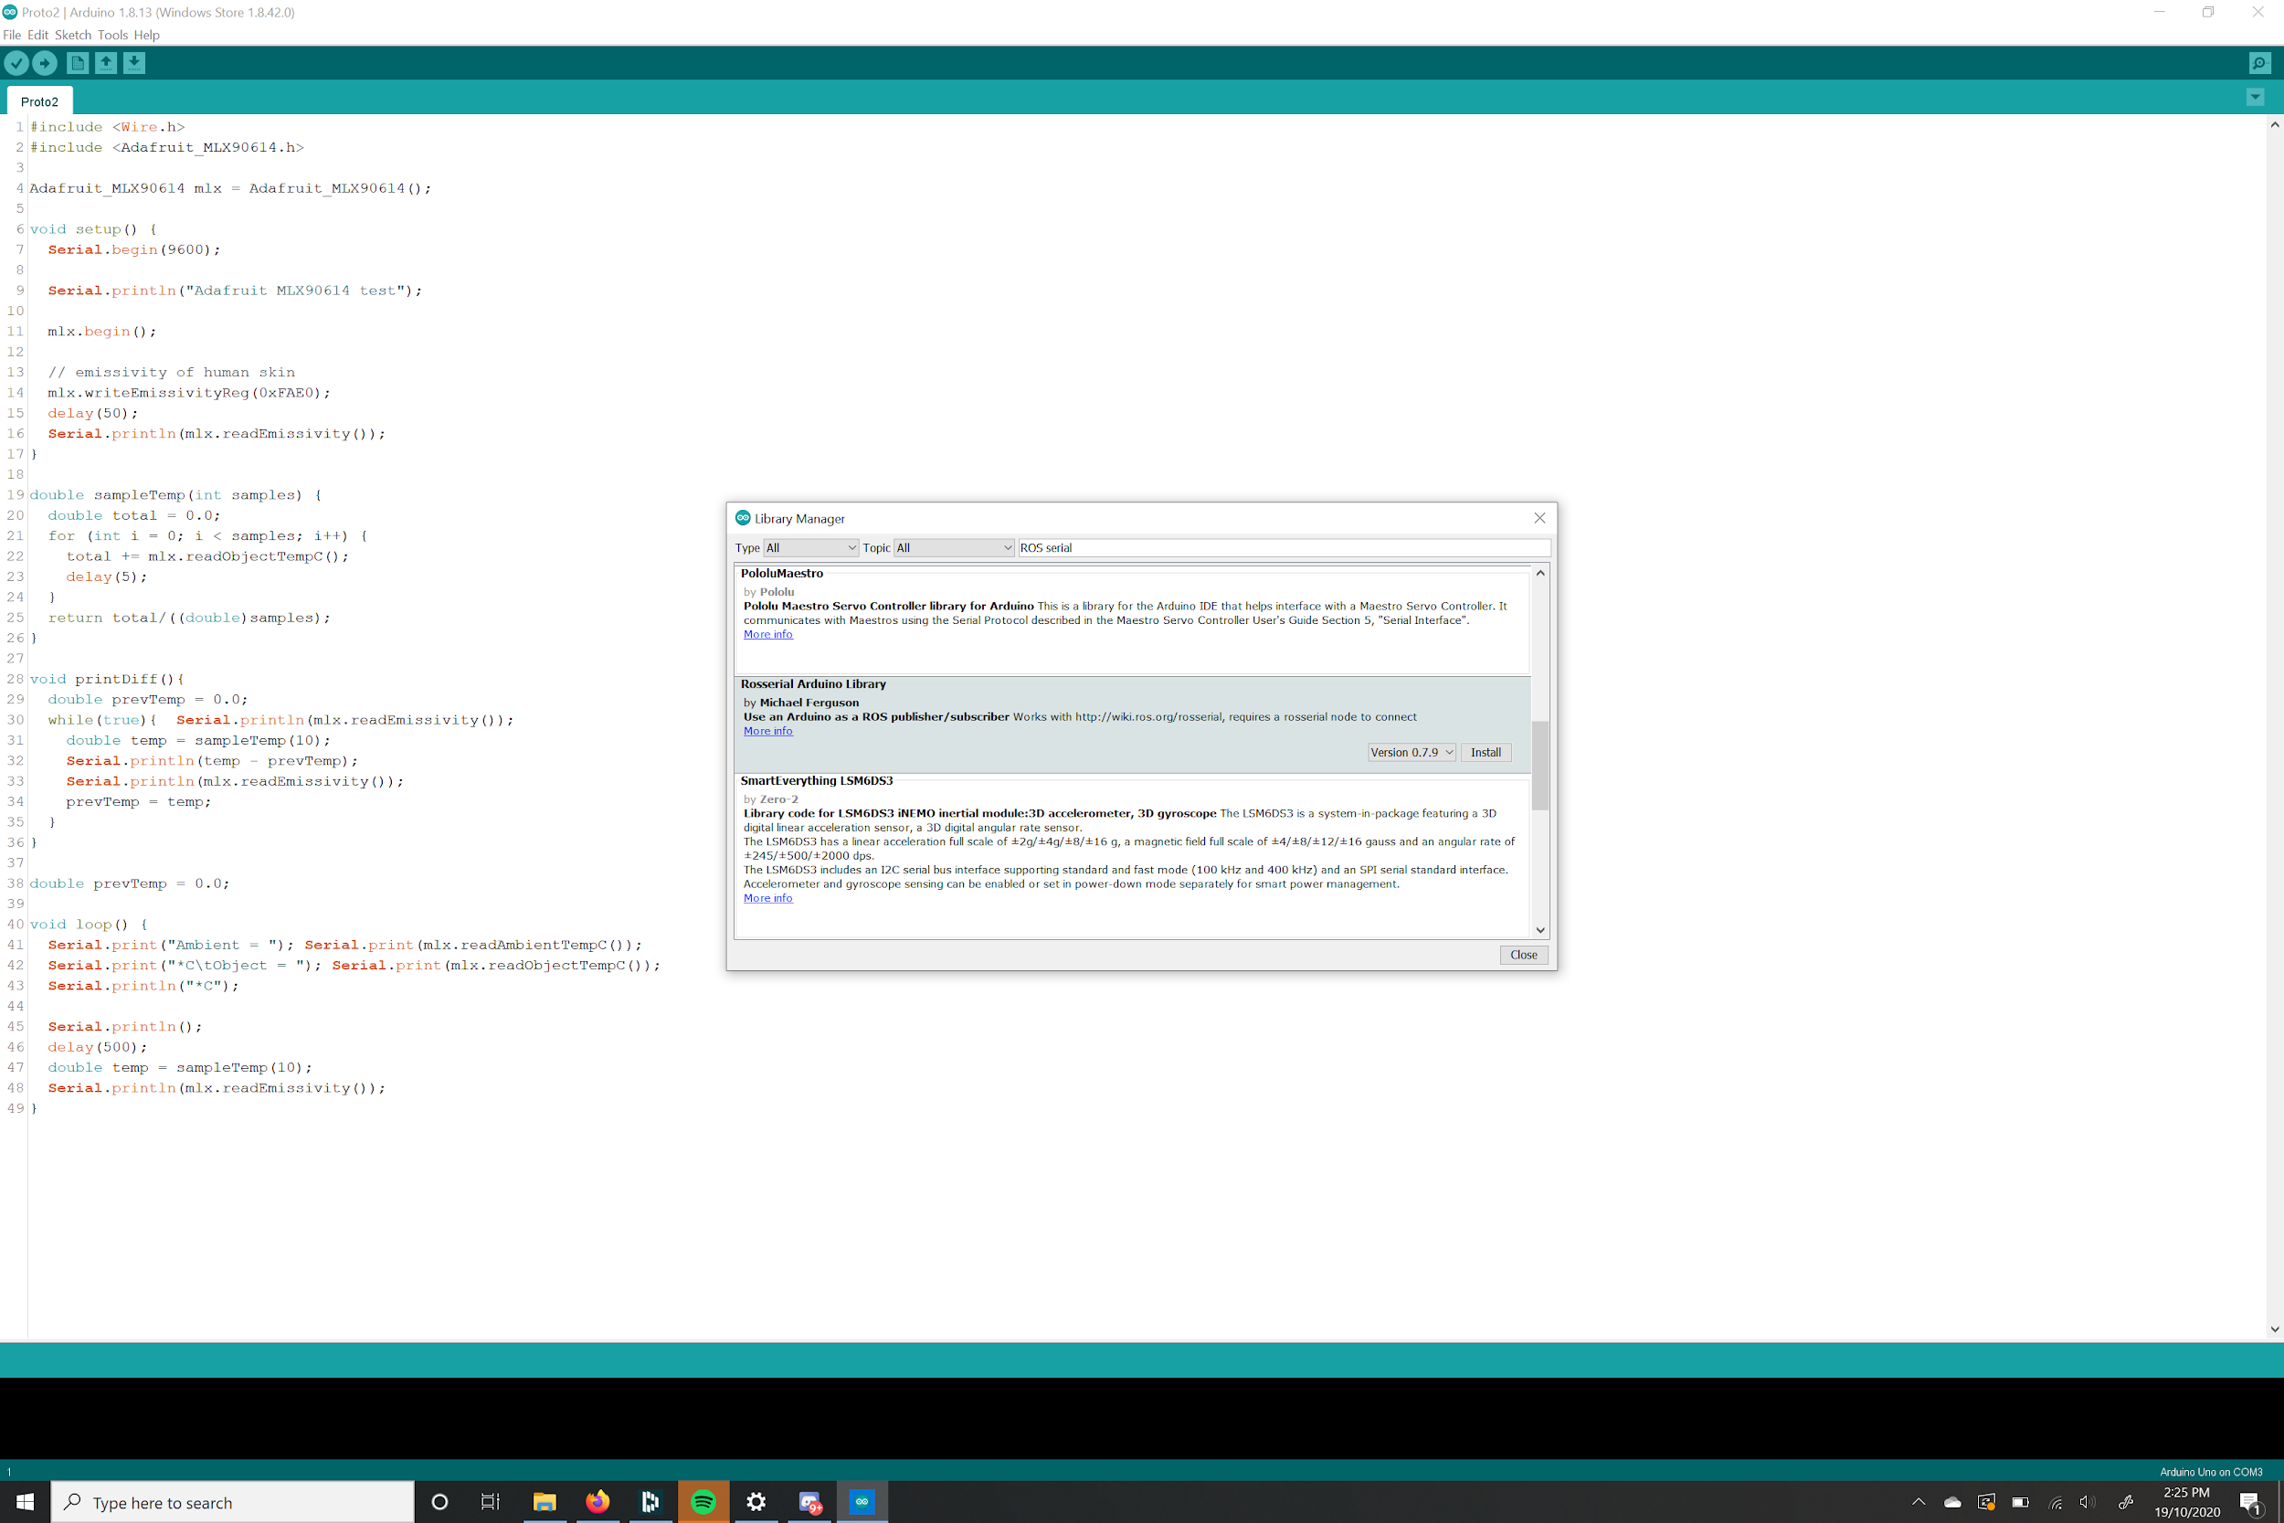

1. Load the following code onto the Arduino Uno.

|  |
| --- |
| **#include <ros.h>** **#include <std_msgs/Float32.h>** **#include <Adafruit_MLX90614.h>**  Adafruit_MLX90614 mlx = Adafruit_MLX90614(); std_msgs::Float32 objtemp_msg; std_msgs::Float32 ambtemp_msg; ros::Publisher pub_objtemp("object_temperature", &objtemp_msg); ros::Publisher pub_ambtemp("ambient_temperature", &ambtemp_msg); ros::NodeHandle nh;   void setup() {   *// Initiate ros node*  nh.initNode();  nh.advertise(pub_objtemp);  nh.advertise(pub_ambtemp);   mlx.begin();   *// emissivity of human skin*  mlx.writeEmissivityReg(0xFAE0);  delay(50); }  void loop() {  while (!nh.connected())  {  nh.spinOnce();  }  objtemp_msg.data = mlx.readObjectTempC();  ambtemp_msg.data = mlx.readAmbientTempC();  pub_objtemp.publish(&objtemp_msg);  pub_ambtemp.publish(&ambtemp_msg);    delay(500);  nh.spinOnce(); } |

1. Once the above code is uploaded to the Arduino, initiate ROS on the receiving device by typing the following commands.

In Terminal 1:

**$** sudo apt-get update

**$** sudo apt-get upgrade

**$** sudo usermod -a -G dialout $USER

**$** roscore

In Terminal 2:

**$** rosrun rosserial_python serial_node.py /dev/ttyUSB0

/dev/ttyUSB0 is the port where the Arduino is connected to the Raspberry Pi

In Terminal 3:

**$** rostopic echo /object_temperature

**$** rostopic echo /ambient_temperature

1. In terminal 3 the temperature reading should be showing in the CLI.

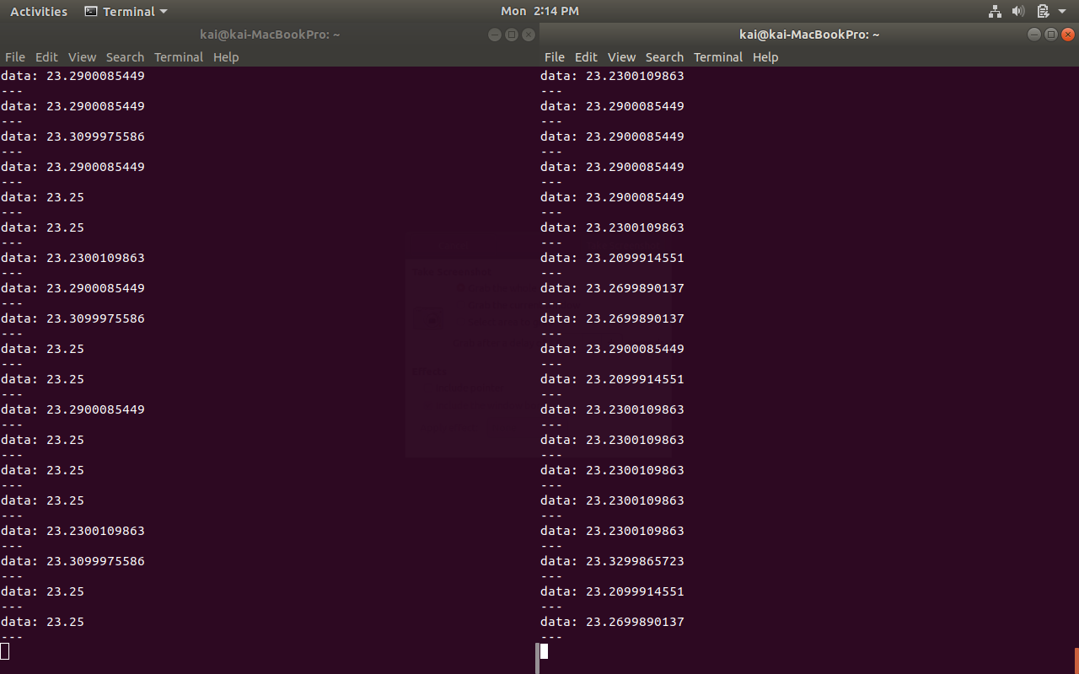

## Conclusion

The Arduino Uno should now be able to transmit data from the sensor directly connected to itself to the given device. This can now be extended to a large range of applications such as sending data directly to a microprocessor for further processing.